SOCIAL IMPACT REPORT
2017
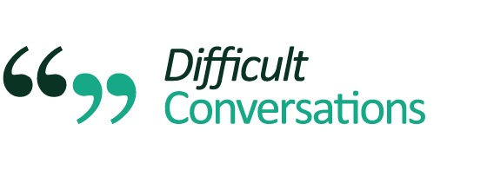

86,064
estimated reach to patients/ end users each month*

1,956
professionals trained

100%
participants recommend training

Difficult Conversations:
Enabling patients to have a good death.

Cumulative Social Impact at 31 December 2017
*Self-declared by participants
Difficult Conversations is a multi-award winning social enterprise. We provide three main activities to work towards achieving our social enterprise mission: Training, Consultancy and Advocacy.

We offer GMC endorsed, experiential, multi-professional training programmes to help professionals build their confidence, skills and knowledge in order to have effective, compassionate ‘difficult conversations’, where they really count. Our training format is highly interactive and provides innovative blended-learning with a popular communication framework.

We offer Learning and Development consultancy to providers and commissioners to help improve processes, efficiency and support services across health and social care settings.

Our Social Impact highlights in period 1 January 2017 – 31 December 2017:

1. We provided 38 training events and trained 420 people. We have also expanded our range of communication skills training.

2. Difficult Conversations training achieves consistently high post-assessment scores from participants. For this period self-reported scores show:
- Improved confidence – 98%
- Improved knowledge – 91%
- Improved skill – 92%
- 99% would use in future practice
- 100% would recommend to a colleague

3. Difficult Conversations delivered our first international training programme in Bermuda.
“I have used several models before, and can honestly say this is the most concise, user-friendly model I have encountered.” Lead consultant
4. Health Education England - two awards achieved to deliver Care Planning and Communication Skills multi-professional training across North West London and Cancer Prevention & Lifestyle Change Conversations with Motivational Interviewing across Wessex.
5. Our training received endorsement from the General Medical Council.

6. Difficult Conversations and NHS Blood and Transplant are co-producing Quality Improvement training for their team, to help save more lives.

7. What our participants say about us:
“Excellent workshop. Very interactive. Role play was helpful – practical and reflective on own practice. Very importantly covered non-verbal as well as verbal skills.”
“Very informative, enjoyable and well delivered”

8. Evidencing our impact - Difficult Conversations welcomed an independent evaluation of Difficult Conversations training with Kings College London.
8: What our participants say about us:

“Excellent workshop. Very interactive. Role play was helpful – practical and reflective on own practice. Very importantly covered non-verbal as well as verbal skills.” -Dr S. GP
“It gave me skills such as reflecting back appropriately in discussions which could diffuse tricky situations.” -MN, Social Worker
“Excellent interactive learning activity.”
-RMN, Care Home
“It made me address my communication style and has given me tangible tools to work with.” -Nurse

9. Difficult Conversations has expanded to offer robust independent development support for organisations.
10. Difficult Conversations is developing a range of accessible online learning resources, such as e-learning, podcasts and tools to complement our training to be available autumn in 2017.

For more information, please contact us on:
reception@difficultconversations.org.uk

